Lab #1: Changing Motion and Error

Handlers: Ethan Alliot, Luis Mata, Alex Sanders, Cade Rosenlund, Ryan Levanen

Objective: The objective of this lab was to learn how to use the Logger Pro app and measure Earth’s Gravity.

Data: 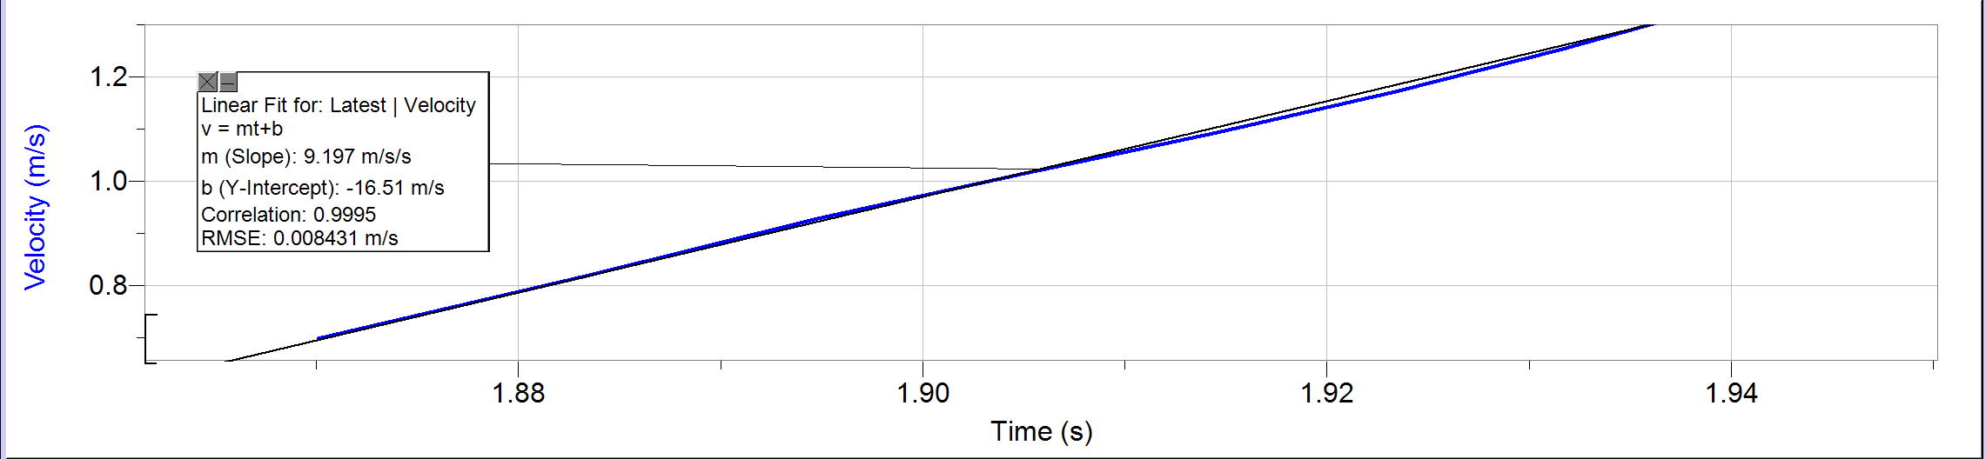

|  |  |
| --- | --- |
| Trial | Acceleration |
| 1 | 9.261 |
| 2 | 9.745 |
| 3 | 9.846 |
| 4 | 9.197 |

Standard Deviation: 0.3306915733

Average Acceleration: 9.51225

Analysis

1. Acceleration due to gravity is a constant
2. Ag = 9.512 ± 0.331 m/s^2
3. ((9.81-9.512)/9.81) X 100% = 3.13%
4. Standard deviation is the amount of variation amongst a set of data values from the mean.

In Conclusion:

In summary, our lab aimed to learn how to use the Logger Pro app and measure Earth's acceleration due to gravity. We found an average acceleration of about 9.512 m/s^2 with a slight variation of 0.331 m/s^2, showing that our measurements were quite consistent. Comparing this to the expected value of 9.81 m/s^2, our result was off by only 3.13%, indicating good accuracy. This experiment confirms that gravity's acceleration on Earth is constant and helps us understand the concept of standard deviation as a measure of data spread.